**Year 11 Physics**

**Waves**

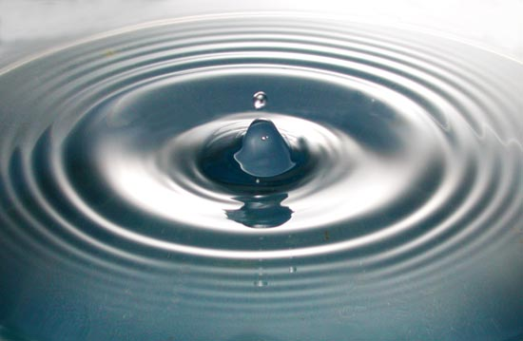

**http://physics.gmu.edu/~satyapal/water_wave.jpg**

**Name:**

**SCSA ATAR Syllabus**

<https://senior-secondary.scsa.wa.edu.au/syllabus-and-support-materials/science/physics>

**Science Understanding**

* waves are periodic oscillations that transfer energy from one point to another
* mechanical waves transfer energy through a medium; longitudinal and transverse waves are distinguished by the relationship between the directions of oscillation of particles relative to the direction of the wave velocity
* waves may be represented by displacement/time and displacement/distance wave diagrams and described in terms of relationships between measurable quantities, including period, amplitude, wavelength, frequency and velocity

*This includes applying the relationships*

$v=fλ T=\frac{1}{f}$

* the mechanical wave model can be used to explain phenomena related to reflection and refraction, including echoes and seismic phenomena
* the superposition of waves in a medium may lead to the formation of standing waves and interference phenomena, including standing waves in pipes and on stretched strings

*This includes applying the relationships for*

Strings attached at both ends and pipes open at both ends

$λ=\frac{2l}{n}$

Pipes closed at one end

$λ=\frac{4l}{(2n-1)}$

* a mechanical system resonates when it is driven at one of its natural frequencies of oscillation; energy is transferred efficiently into systems under these conditions
* the intensity of a wave decreases in an inverse square relationship with distance from a point source

*This includes applying the relationship*

$I∝\frac{1}{r^{2}}$

**Science as a Human Endeavour**

Application of the wave model has enabled the visualization of imaging techniques. These can include:

* medical applications, such as ultrasound
* geophysical exploration, such as seismology

Noise pollution comes from a variety of sources and is often amplified by walls, buildings and other built structures. Acoustic engineering, based on an understanding of the behavior of sound waves, is used to reduce noise pollution. It focuses on absorbing sound waves or planning structures so that reflection and amplification do not occur.

****Proposed timeline****

|  |  |  |  |  |
| --- | --- | --- | --- | --- |
| **Wk** | **#** | **Topic** | **PowerPoint** | **STAWA Questions** |
| 9 | 1 | Wave basics | 1-5 |  |
| 9 | 2 | Mechanical waves | 6 |  |
| 9 | 3 | Electromagnetic waves | 7-8 |  |
| 9 | 4 | Transverse waves | 9 |  |
| 9 | 5 | Longitudinal waves | 10-11 |  |
| 10 | 1 | Wave diagrams | 12-16 | Set 19 |
| 10 | 2 | Reflection | 17-20 |  |
| 10 | 3 | Reflection | 17-20 |  |
| 10 | 4 | Refraction | 21-25 |  |
| 10 | 5 | Staff PL |  |  |
| 1 | 1 | Refraction | 21-23 |  |
| 1 | 2 | Wave speed | 24 |  |
| 1 | 3 | Total internal reflection | 25 |  |
| 1 | 4 | **Speed of sound in vibrating column - Experiment** |  |  |
| 1 | 5 | Superposition and beats | 26-27 |  |
| 2 | 1 | Interference in 2D | 28-30 |  |
| 2 | 2 | Standing waves | 31-37 |  |
| 2 | 3 | Standing waves | 31-37 |  |
| 2 | 4 | Resonance | 38-41 |  |
| 2 | 5 | Resonance | 38-41 |  |
| 3 | 1 | Intensity | 42-43 | Set 20 |
| 3 | 2 | Noise pollution | 44-45 |  |
| 3 | 3 | Revision |  |  |
| 3 | 4 | Revision |  |  |
| 3 | 5 | **Waves Topic Test** |  |  |

**Glossary**

|  |  |
| --- | --- |
| **Word** | **Definition** |
| Oscillation |  |
| Medium |  |
| Transverse wave |  |
| Longitudinal wave |  |
| Electromagnetic wave |  |
| Mechanical wave |  |
| Period |  |
| Frequency |  |
| Wavelength |  |
| Amplitude |  |
| Reflection |  |
| Refraction |  |
| Echo |  |
| Constructive interference |  |
| Destructive interference |  |
| Standing wave |  |
| Resonance |  |
| Natural frequency of vibration |  |
| Forced vibrations |  |
| Intensity |  |

**Waves**

* Waves are periodic oscillation that transfer energy from one point to another
* Repeated variations back and forth that transport energy but not matter

**Wave equation**

$$v=fλ$$

$$v=velocity \left(m s^{-1}\right)$$

$$f=frequency \left(Hz=s^{-1}\right)$$

$$λ=wavelength \left(m\right)$$

$$\frac{1}{f}=T=period (s)$$

* Frequency: number of waves passing a point each second
* Period: The time it takes for a wave to repeat itself
* Wavelenght: length of 1 complete wave
* Amplitude: the largest distance away from the mean position that a particle moves before returning

**Mechanical waves**

* Physical disturbances of matter
* E.g. sound waves
* Requires the presence of matter, known as a medium
* Wave transmits energy through the medium without transporting the medium
* No medium = no wave
* No sound in space
* Wave speed depends on medium and wave type

**Electromagnetic waves**

* Way of modelling some of light’s behavior
* Light consists of synchronized oscillations of magnetic and electric fields
* No need for matter as a medium
* Propagates through vacuums
* ‘Transverse’ wave
* Travels at the speed of light 3x108 ms-1

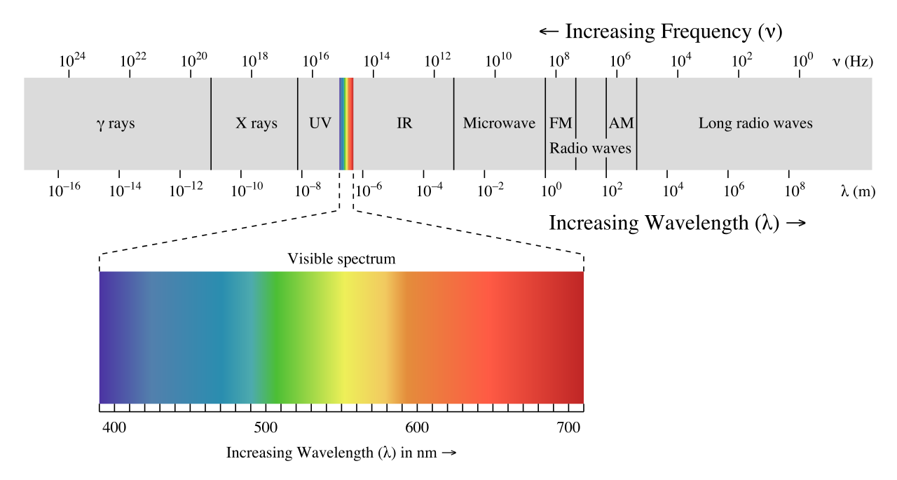

* c is constant so frequency and wavelength are simply inversely proportional
* Higher frequency means higher energy e.g. X-ray, gamma rays
* Frequency/wavelength determines colour of visible light

**Transverse waves**

* Direction of propagation (direction energy is transmitted) is perpendicular to direction of oscillation (direction particles vibrate)

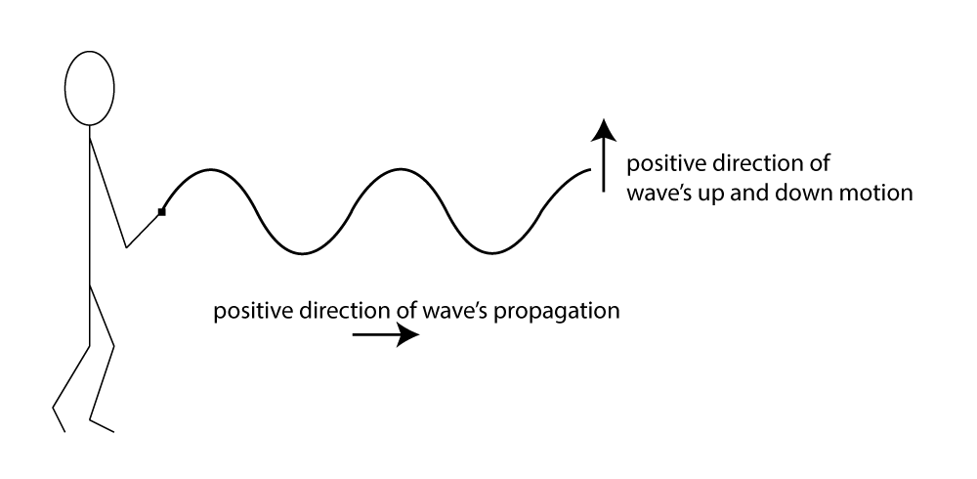

http://digitalsoundandmusic.schwartzsound.com/wp-content/uploads/2014/05/transverseWaveFig1_8.png

**Longitudinal waves**

* Direction of propagation (direction energy is transmitted) is parallel to direction of oscillation (direction particles vibrate)
* Compressions: high pressure zones
* Rarefactions: low pressure zones
* Frequency determines pitch, high frequency means high pitch
* Amplitude related to ‘loudness’

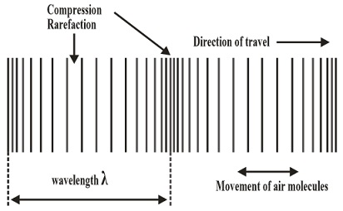

https://embibe-cdn.s3.amazonaws.com/resources/images/11932_Diagram.jpg

**Representing waves**

* Typically drawn as displacement/time or displacement/distance ‘graphs’
* Both diagrams look like transverse waves whether the wave represented is transverse or longitudinal

**Displacement/Time**

**Displacement/Distance**

**Wavefronts and rays**

* Waves can be represented in 2D diagrams using wavefronts and/or rays
* Wavefronts show the locations of peaks (or troughs but not both)
* Rays show the direction of wave propagation
* Rays and wavefronts are perpendicular

Wave source

Wavefronts

**Reflection**

* When a wave strikes a surface, energy can be absorbed, transmitted through, or reflected, typically a mix of all three
* Waves reflect off surfaces obeying the law of reflection
* Angle of incidence = angle of reflection
* Easiest to picture treating the waves as rays

Angle of reflection

Angle of incidence

Normal

Incident ray

Reflected ray

**Echoes**

* Echoes are heard when a single sound wave reaches an observer twice with a significant time delay in between (around 0.1s)
* Caused by reflection of a wave of a surface
* Works best off a smooth surface that doesn’t scatter the wave
* Sound heard when you shout and then again when the reflected sound returns

**Echolocation, Ultrasound, SONAR & Seismic imaging**

* Reflection of waves can be used for internal imaging at a variety of scales
* Short wavelengths used to see small detail, large wavelengths used to see large structures
* Sound emitted from a source, time measured for echo to return from a reflector, if speed known then distance to reflector  
  can be determined, multiple echoes reveal multiple layers
* The time that elapses for a depth sounder to receive the reflected signal is 0.60s and the speed of sound in seawater is 1500ms-1 determine the depth of the water.
* Thunder is heard 4s after lightning is observed, how far away is the lightning? (v=330m/s)

* A person 150m from a cliff fires a bullet, how long would it take for the echo to reach her?

**Refraction**

* When a wave is transmitted from one substance to another it can change speed, since speed depends on the medium
* When a wave changes speed, it can change direction,   
  this is known as ‘refraction’
* If a wave speed up, it bends away from the normal
* If a wave slows down, it bends towards the normal
* Speed changes but frequency remains constant so wavelength   
  changes
* If a wave strikes a surface parallel to the normal,   
  there is no refraction

**Drawing refraction**

* Best shown with a combination of ray and wavefronts

normal

surface

slow

fast

normal

surface

fast

slow

**Wave speed**

Mechanical waves

* Rigidity of medium (faster in solid than liquid, faster in liquid than gas)
* Temperature (faster at higher temperatures)
* Density(faster in lower density substances)

EMR (Light)

* Refractive index (c/v)
* Varies with wavelength/frequency

**Refraction through a gradient**

* When wavespeed changes gradually through a gradient, the refraction is gradual, the wave follows a curved path
* If the wave is speeding up it bends away from parallel to the direction of the gradient
* If the wave is slowing down it bends towards parallel to the direction of the gradient
* The result is that the wave will bend towards the slower end of the gradient
* This is most common where temperature gradients in air or water cause a wavespeed gradient

**Total internal reflection**

* Complete reflection when a wave would speed up

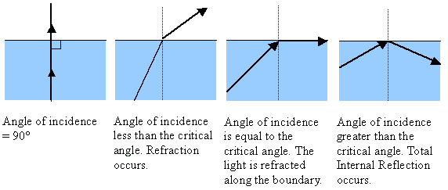

**Superposition**

* When two waves overlap, they interfere
* Can be thought of as a vector sum of the two waves
* The waves pass through each other unchanged
* If the waves are out of phase (i.e. peak meeting trough) then destructive interference occurs (decreased amplitude)
* If the waves are in phase (i.e. peak meeting peak) then constructive interference occurs (increased amplitude)

**Beats**

* If two sound waves of similar but different frequencies are present in the a medium, they interfere to create ‘beats’
* The beats are perceived as variations in volume
$$f_{beats}=\left|f_{1}-f_{2}\right|$$

* Used to tune instrument by ear, as the   
  two frequencies become closer the   
  frequency of the beats slows

**Interference in 2D**

* Complex patterns emerge with interference in 2D
* i.e. stereo audio resulting in quiet and loud corridors
* Wavefronts show crests, troughs centered between wavefronts
* Zones of constructive interference (antinodal lines) in blue, zone of destructive interference (nodal lines) in-between

**Persistent interference**

* The two sound sources must be coherent (in phase or constant phase relationship)
* Similar amplitudes
* Same wavelength

If 2 speakers emitted 425 Hz coherent sounds and were 2.40m apart and the speed of sound is 340m/s, then:

* What is the wavelength of the sound?
* what would you hear as you walked across in front of the speakers?
* What would you hear at a point 7.00m in front of speaker 1?

**Standing waves**

* If two waves of the same frequency are propagating in opposite directions in a medium a standing wave will be established
* The second wave can simply be a reflection of the first
* Wave doesn’t appear to move, hence “standing wave”
* Immobile points of zero amplitude: nodes (destructive interference)
* Immobile points of maximum amplitude: antinodes (constructive interference)
* Antinodes separated by half a wavelength

**Standing waves in strings**

$$λ=\frac{2l}{n}$$

* A violin string has a length of 22.0 cm. It is vibrating with its fundamental frequency of 880 Hz. What is the wavelength of this frequency?
* What is the frequency of the 2nd overtone?

**Standing waves in open pipes**

$$λ=\frac{2l}{n}$$

* A flute is an open ended instrument and speed of sound is 340 m/s:
* What is the wavelength of the 1st harmonic in a 50.0cm flute?
* What is the 2nd harmonics frequency?

**Standing waves in closed pipes**

$$λ=\frac{4l}{(2n-1)}$$

* The ear canal is a closed tube (ear drum) and is approximately 3.00 cm long in an adult. If the speed of sound in air is 340 ms-1:
* What is the fundamental frequency of the ear canal?
* What is the frequency of the next resonating frequency?
* Explain why some frequencies are better heard than others.

**Resonance**

* An external driver can make a system oscillate with greater amplitude at specific frequencies
* The specific frequencies are the resonant frequencies for the system
* Occurs due to easy transfer of energy between two forms in the system, typically kinetic energy and a potential energy e.g. pendulum
* Responsible for the characteristic pitch of the sound made by a struck piece of metal, glass or wood other vibrations fall away rapidly but vibrations at a resonant frequency persist at a greater amplitude
* Harmonics observed in instruments are different resonant frequencies of those instruments with the frequency of each harmonic being a multiple of the   
  fundamental frequency

**Forced vibrations**

* A vibrating object can cause another object it is touching to vibrate at the same frequency
* E.g. violin string vibrates at resonant frequency, forces the violin body to vibrate at the same frequency, creates a larger surface area to transfer the vibrations to the air

**Sound intensity**

* Obeys the inverse square law
$$I∝\frac{1}{r^{2}}$$

* Sound intensity measured in decibels (dB) unusual unit, bels are logarithmic but each bel is then split into 10 parts hence decibel
* An increase of 10 dB is an increase by a factor of 10
* An increase of 20 dB is an increase by a factor of 100
* Intensity related to amplitude
* Loudness is dependent on intensity but it is subjective/observer dependent

**Noise pollution**

* Hearing alerts humans to changes in their environments - can’t turn it on and off voluntarily.
* Sounds become noise when they are unwanted—when they interfere with thinking, concentrating, working, talking, listening, or sleeping.
* Noise makes hearing, concentrating, and working more difficul
* It disturbs sleep. Insufficient or poor quality sleeps results in stress, fatigue, and changes in body’s chemical balances.
* Interferes with cognitive functions, including attention, concentration, memory, reading ability, and sound discrimination
* Long term exposure to noise from road, rail, and air traffic results in physiological and psychological stress, which indirectly may contribute to heart disease, and high blood pressure.
* Chronic or repeated exposure to sounds at or above 85 decibels can cause hearing loss.

**Noise management**

* Problematic reflectors e.g. wall next to freeway can be changed to rough, flexible surfaces to increase the absorption and dispersal of energy
* Replace riveted joins with welded joins in machinery
* Soft furnishing on floors and walls, carpets, curtains
* Acoustic silencer (muffler) on car exhausts
* Isolation chambers for particularly noisy machinery
* Noise cancelling: anti-noise

**Problems**

**Mechanical Waves- self study section**

Use the internet: <http://www.physicsclassroom.com/class/sound> Answer the questions fully.

1. Compare a mechanical wave with an electromagnetic wave giving definitions, differences, similarities and examples. Use a table for this.
2. Mechanical waves can be drawn in 2 different types of graphs. Draw a displacement vs time and a displacement vs distance graph and explain the difference between the two.
3. Define the wave terminology giving the symbol and units for:
   1. Amplitude
   2. Frequency
   3. Wavelength
   4. Period
   5. Speed

Draw a labelled diagram to support your answer.

1. Compare transverse and longitudinal waves. Draw a labelled diagram of each with a definition and examples.
2. Research three types of seismic waves: their properties, characteristics and effects.
3. Carry out the practical with a slinky to represent transverse and longitudinal waves.
4. Speed of waves. From v = s/t derive v = f x λ f = 1/T. Define each symbol.
5. What is the relationship between the frequency and the period of a wave?
6. Where would you find the maximum displacement of the turns in a slinky spring that has a transverse wave passing through it?
7. What effect does the distance the vibrating particles making up a wave are moved from their mean position have on the amplitude of a wave?
8. A boy 1.2 km from a firing range hears the report of a gunshot. How long did it take the sound to travel from the range to the boy? The speed of sound in air is 340 ms-1.
9. A concert pianist plays a single note of frequency 310 Hz. The wavelength is 1.07 m. What is the speed of sound in the air at that time?
10. Classify the following examples as mechanical or electromagnetic, and as transvers or longitudinal waves.
    1. A pulse transmitted along a string stretched the string at right angles to the direction of motion of the pulse.
    2. The wave produced by dropping a stone into a calm pond.
    3. Sound waves produced by a radio.
    4. Visible light from a spotlight.
    5. Waves produced in the air by vibrating vocal cords.

**Sound waves**

1. What type of wave is a sound wave?
2. How are sound waves represented?
3. Draw a sound wave below in different colours and a key draw in :
4. Same pitch but softer sound.
5. Higher pitch with same volume.
6. Lower pitch and louder.
7. Referring to a) a guitar b) trombone, how can the pitch be altered?
8. Do Questions set 10.2 in Nelson pg 321-322.
9. Reflection of sound waves: read Nelson pg 323 -327, making a summary.
10. Carry out the experiment : Reflection of light using Hodson light ray box and power pack to prove the law of reflection.
11. Carry out experiment refraction of light using Hodson light box to prove the law of refraction.
12. Make notes on refraction of sound waves pg 329.

